**Message Class:**

In this class, I declared the attributes and made a constructor of this class

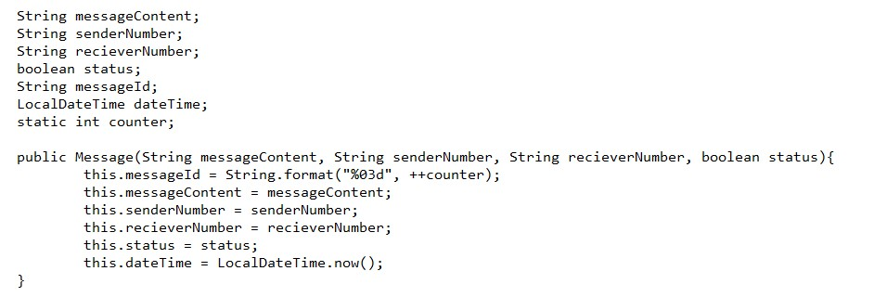 Which sets the values of attributes.

As shown in this pic the ID is created automatically.

And I made the setters and getters foe these attributes.

**MessageApp class:**

In this class I made different functions.

* First I made a block to store some messages to a 2d array already.

1. **sendMessage:**

* Then I made a sendMessage Function. This function takes input from user and store this in a 2D array.

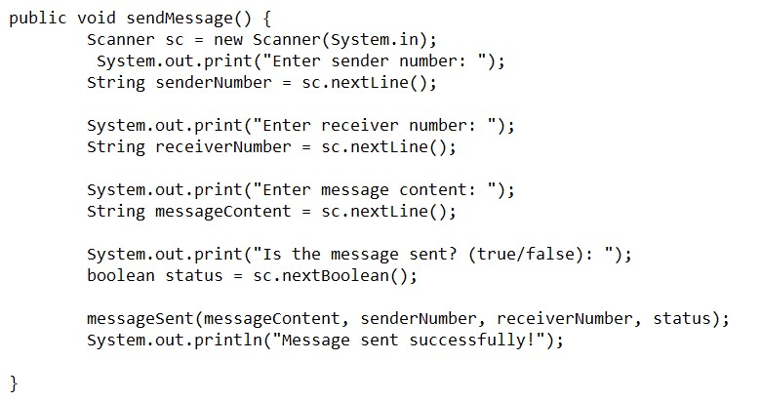

1. **Display function:**

* I made a function to display all the messages saved in a 2d array.
* I made a second display function which displays the message sent to a specific user.

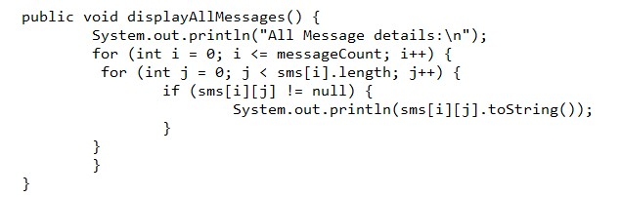

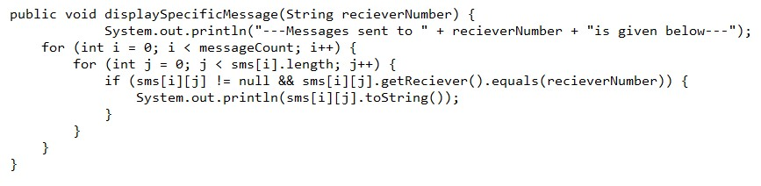

1. **searchMessage Function:**

In this function I searched a specific message by its id and the displayed it.

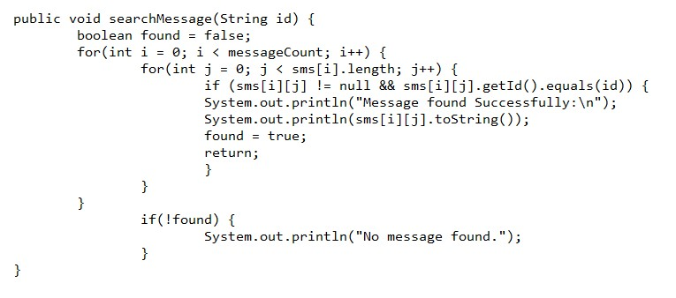

1. **checkStatus fuction:**

In this function I checked the status of the specific message by using its Id. By matchinf id, I checked the status.

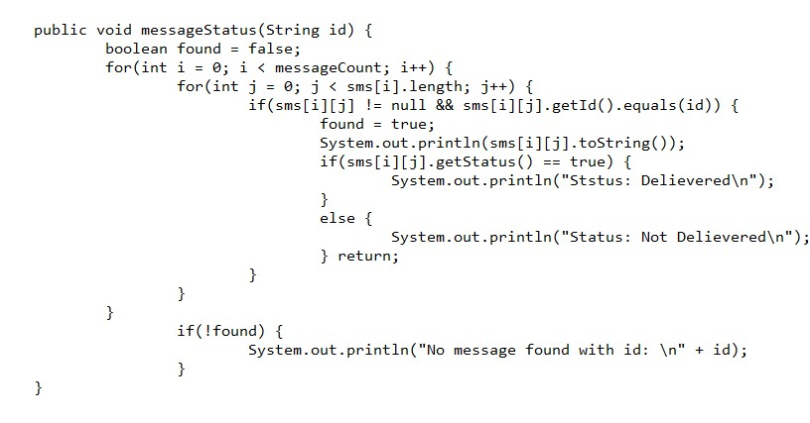

1. **deleteMessage Function:**

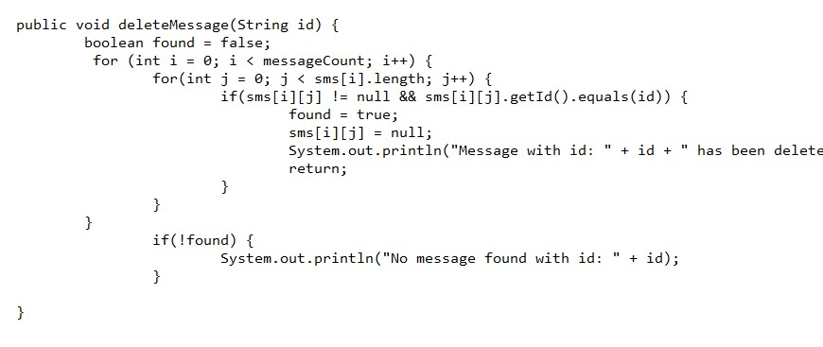I made this function by machind the id of a message which I wanted to deleted and when id is matched I made it null.

1. **Sorting Function:**

I made this function to sort the messages. By this function I sorted all the messages in reverse order. The last message is on First index and so on.

